**Price Bubble in Commodity Market**

This study conducts a comprehensive empirical investigation into the existence, timing, and duration of speculative price bubbles across commodity markets using the GSADF and BSADF testing frameworks. Unlike prior research which often focused on individual commodities or financial assets, this paper examines 35 distinct commodities from three key sectors—agriculture & livestock, energy, and metals—over a substantial time horizon spanning January 1980 to December 2021, with monthly frequency. The methodology applies the Generalized Supremum Augmented Dickey-Fuller (GSADF) test, which is well-suited for detecting multiple bubbles within a time series and is robust to structural breaks and varying window lengths. Critical values for statistical significance were derived using Monte Carlo simulations with 10,000 replications. The analysis is twofold: first, each commodity is individually tested for explosive behavior; second, panel tests are employed to assess bubble behavior within sectoral groups. Results reveal that 32 of the 35 commodities experienced statistically significant bubbles at the 1% level, with notable exceptions including banana, cocoa, and orange juice, suggesting their relative resistance to speculative surges. Commodities such as tin, tobacco, and gold exhibited the most frequent and prolonged bubble episodes, many of which coincided with global financial crises, particularly during 2007–2008 and 2010–2011. Additionally, the study identifies and records 175 distinct bubble periods, including durations exceeding six months for a substantial subset. Panel test results further confirm sectoral vulnerabilities, indicating that the energy and metals sectors are more prone to price bubbles than agriculture & livestock. These findings provide valuable insights for investors, analysts, and policymakers by highlighting which commodities are most susceptible to speculative dynamics, and by suggesting safer asset allocations in periods of market instability.

*Applies Panel based GSADF and BSADF test to panel data of different commodities.*

**Granger Causality and Cointegration During Stock Bubbles and Market Crashes**

Performs GC and Coint analysis on stock indices and macro econ time series. A brief sections shows that cointegration breaks when one of the time series moves into a Bubble territory

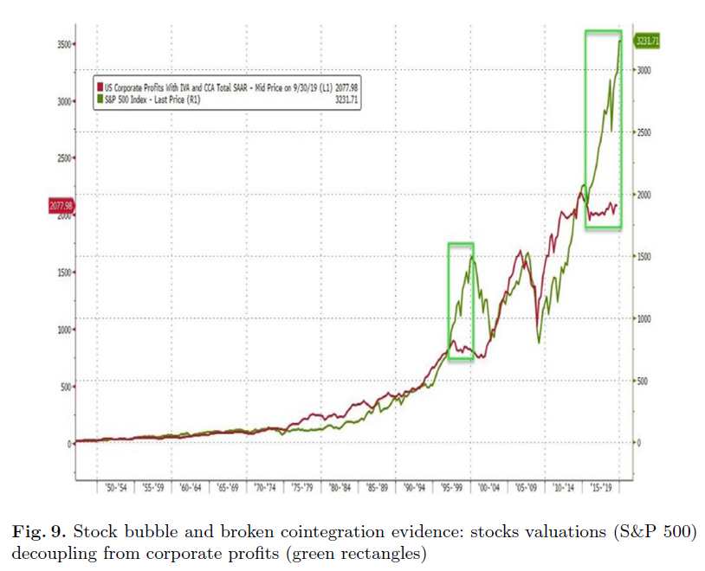

**BUBBLES DETECTION FOR INTER-WAR EUROPEAN HYPERINFLATION: A THRESHOLD COINTEGRATION APPROACH**

The study builds on Diba and Grossman’s (1988) insight that, in the presence of an explosive bubble, the residuals from a regression of asset prices on fundamentals should remain non-stationary, regardless of differencing. To test for inflationary bubbles, the authors use a two-step cointegration approach based on Engsted’s method. First, they test whether real money balances (Mₜ − Pₜ) and expected inflation (ΔPₜ₊₁) are cointegrated. Stationary residuals indicate a valid model. They then test for cointegration between real money balances and money growth (ΔMₜ). If this second regression fails to yield stationary residuals, it suggests a bubble—since money growth lacks the bubble component, the explosive behavior remains. If both regressions yield non-stationary residuals, the model is likely misspecified. The stationarity of the residuals in this study is tested using the Threshold Autoregressive (TAR) unit root test developed by Caner and Hansen (2001).

**Bursting the Bitcoin Bubble: Do Market Prices React Fundamental Bitcoin Value?**

This paper examines whether the price of Bitcoin reflects its underlying economic value or contains speculative bubbles. The authors define Bitcoin’s **fundamental value** as the **marginal cost of mining**, which depends on the network’s difficulty adjustment mechanism. They argue that since Bitcoin is produced like a commodity, its price should align with the cost of production in the long run.

To test this, they first verify whether Bitcoin’s market price and its mining cost share a stable long-run relationship using the Engle-Granger cointegration test. Once this is confirmed, they apply two advanced bubble detection methods—SADF and GSADF tests—to identify periods of explosive price behavior that may indicate bubbles.

They apply these tests to:

1. The raw Bitcoin price,
2. The residuals from the price–cost cointegration model, and
3. The log-difference between price and fundamental value (as a robustness check).